Visualization in Python
Visualization tools in Python
- Matplotlib
- Bokeh
- Altair
- Seaborn
- Chaco
- mayavi
Matplotlib
matplotlib package provides a python library for creating static, animated, and interactive data visualizations in Python. Matplotlib is primarily a library for making 2D plots. The functions in the library can create publication quality plots.
- Matplotlib has interactive features like zooming, panning, and updating.
- It supports many different GUI backends.
- It can export graphics to all of the common vector and raster graphics formats: PDF, SVG, JPG, PNG, BMP, GIF, etc.
- It provides an API to create plots from scratch (require low-level commands).
Matplotlib provides a high-level interface for creating plots through the pyplot sub-module. The interface provided by pyplot is similar to the one provided by MATLAB.
Matplotlib also provides a low-level interface that gives more control for creating plots. This is an object-oriented interface.
Pyplot
This sub-module of matplotlib is typically imported as:
import matplotlib.pyplot as plt
In order to better understand the interface provided by pyplot, it is important to understand various parts of a graphical visualization as shown in the figure that follows.
Figure Object
A Figure object is the top level container for all the plot elements. In other words, every plot resides in a Figure object. New figure can be created as
fig1 = plt.figure()
fig1 is the Figure object (an empty figure) to which plot(s) can be added. This object represents the whole figure.
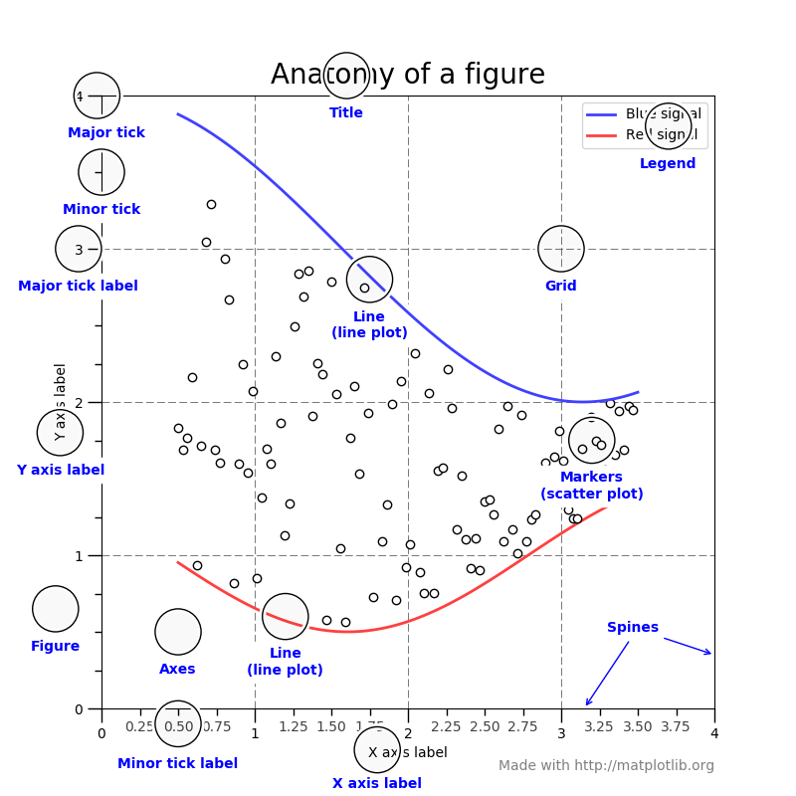
subplot Object
A subplot object represents a plot. A Figure can contain one or more plots (subplot objects). A plot can be added in a Figure through its add_subplot method as
ax1 = fig1.add_subplot()
Here, ax1 is a subplot object added to the Figure object fig1. Actually, ax1 is an object of a subclass AxesSubplot of the Axes class. Issuing a subsequent plotting command plots on the current subplot within the current figure.
Plotting functions in the pyplot module automatically create a Figure and a plot within it if there is no Figure and a plot in it exist.
Multiple subplots in a figure are arranged in a grid of rows and columns. The following command creates a 2 x 2 logical grid in Figure fig2, and adds 1st subplot ax11 in it.
ax11 = fig2.add_subplot(2, 2, 1)
A Figure and a subplot within it can be conveniently created together using the subplots function as in
Fig, axes = plt.subplots()
Here axes is an Axes object within the Figure object Fig.
Fig2, axesA = plt.subplots(2, 2)
Here, axesA is a 2 x2 array of Axes objects within Figure object Fig2.
The spacing around the subplots can be adjusted using the subplots_adjust function.
Plot Function
This function plots y versus x as lines and/or markers.
Example
x = np.linspace(0, 2*np.pi, 100)
plt.plot (x, np.sin(x), label = ‘Sine’)
plt.plot (x, np.cos(x), label = ‘Cosine’)
plt.title(“ Sine and Cosine”)
plt.legend()
Above commands result in the following plot.
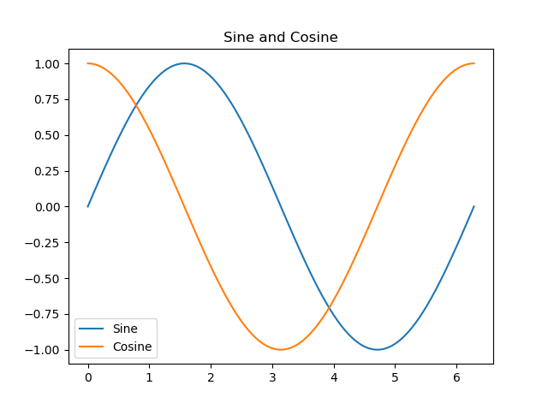
Plotting functions in Pyplot
Acorr bar barh boxplot Hist
hist2d pie plot scatter
Each plotting function has several arguments to configure various components of the plot.
Saving Figures
The active figure can be saved to file using plt.savefig. This function is equivalent to the figure object’s savefig method. For example, to save an SVG version of a figure, you need to type:
plt.savefig('figpath.svg')
The file type is inferred from the file extension.

